Objective Questions

- What is total number of tables present in the data?
Ans. The given data has 2 tables on two different sheets.

- What is the total no. of attributes present in the data?
Ans. In given Data there are 22 attributes. 20 attributes in table from Raw data sheet and 2 in table of Country description sheet.

- How many categorical columns are there in the data? [Search about categorical and continuous data, and try to answer this question]
Ans. There are 15 categorical columns in given data.

- The data consists of some inconsistent and missing values so ensure that the data used for further analysis is cleaned.
Ans. Longitude and Latitude columns were deleted from the data. There were 9 blank cells in cuisine column which were replaced According to country code and highest occurring Cuisine.
Note : - Longitude and latitude cannot be replaced by mean of mode because they define specific place or location and we don’t need it for getting insights so they were deleted. The blank cells in Cuisine were replace by most occurring cuisine in that country.

- Using the LookUp functions, fill up the countries in the original data using the country code.
Ans. The VLOOKUP formula used for fetching country names is
=VLOOKUP(Reference cell,'country description'!$A$2:$B$16,Index Number)
Note : - We need country named in original data so added new Column in Raw data sheet and fetched the country names using above given formula.

- Create a table to represent the number of restaurants opened in each country.
Ans. I have created a Pivot table to show the number of restaurants in each country.
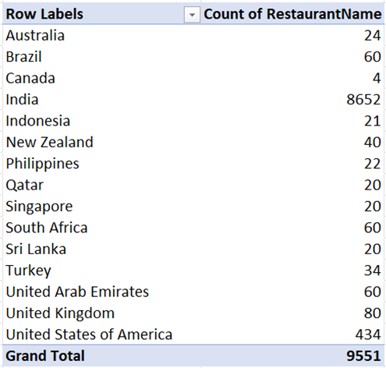

- Also, the management wants to look at the number of restaurants opened each year, so provide them with something here.
Ans. Created a pivot table to show number of restaurants opened each year.
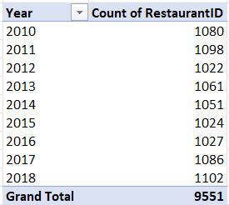
- What is the total number of restaurants in India in the price range of 4?
Ans. The total number of Restaurants in India with price range of 4 is 388.
Note : - Using COUNTIFS function
=COUNTIFS($U:$U,"India",$O:$O,4)

- What is the average number of voters for the restaurants in each country according to the data?
Ans. The Average number of voters for restaurants in each country is represented as below
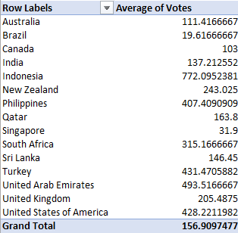

- Calculate the average rating for all the restaurants that have price_range < 4 and provide online delivery. Use only the “IF” function, Logical Operators, ad Aggregation functions to solve this problem. [Note: Don’t use Conditional aggregation in this question.]
Ans. The average rating for all the restaurants that have price_range < 4 and provide online delivery is 3.27381151
Note : - AVERAGEIFS function was used which is given below
=AVERAGE(IF(('Raw Data'!O2:O9552<4)*('Raw Data'!L2:L9552="Yes"),'Raw Data'!S2:S9552))

- Using Conditional formatting highlight the rows of restaurants that are located in the countries or cities that you’ve suggested to the management for opening new restaurants.
Ans. Rows of restaurants that are located in the countries or cities that you’ve suggested to the management for opening new restaurants are highlighted with orange colour.
- Note : - You can see it in Excel sheet that the rows are been highlighted on the basic of country upon checking on the results I have suggested 3 country’s where the management can open new restaurants,
- New Zealand - The total number of restaurants present in this country is 40. No online food delivery is provided in any of these restaurants. The Average rating of all the restaurants is 4.34. The overall price range for this country is 1-4. The growth in number of restaurants is seen after 2016.
- Philippines - The total number of restaurants present in this country is 22. No online food delivery is provided in any of these restaurants. The Average rating of all the restaurants is 4.42. The overall price range for this country is 2-4. The growth in number of restaurants is seen after 2016.
- Turkey - The total number of restaurants present in this country is 34. No online food delivery is provided in any of these restaurants. The Average rating of all the restaurants is 4.3. The overall price range for this country is 2-4. The growth in number of restaurants is seen after 2017.

- Create a new customized price column that consists of the abbreviation/symbol of the currency along with the Average_cost_for_two values. [Use string operations to do this task]
Ans. New customized price column that consists of the abbreviation/symbol of the currency along with the Average_cost_for_two value was created using text to column and concate function
Note : - At first, I used Text to column to extract the symbol of currency from the existing column currency and then used the concate function in Newly created column to get it together. The function used is given below
=CONCAT(J2,"",Q2)
- How can you create an array formula in Excel or Google Sheets to count the number of restaurants listed that do not offer online delivery, are in the lowest price range, and have an average cost for two people less than or equal to 250 Indian Rupees?
Ans. An array formula in Excel to count the number of restaurants listed that do not offer online delivery, are in the lowest price range, and have an average cost for two people less than or equal to 250 is 1685 .
=SUM(COUNTIFS('Raw Data'!O2:$O$9552,"1",'Raw Data'!L2:$L$9552,"No",'Raw Data'!X2:$X$9552,"<=250"))
Subjective Question
- Suggest a few countries where the team can open newer restaurants with lesser competition. Which visualization/technique will you use here to justify the suggestions?
Ans. After studying the data I came on conclusion that to open the Restaurant minimum three to four parameters should be taken under consideration.
I suggest that the countries where the Company should open the Restaurants are
- New Zealand.
- Philippines.
- Turkey.
Insights and Approach: -
- New Zealand - The total number of restaurants present in this country is 40. No online food delivery is provided in any of these restaurants. The Average rating of all the restaurants is 4.34. The overall price range for this country is 1-4. The growth in number of restaurants is seen after 2016.
- Philippines - The total number of restaurants present in this country is 22. No online food delivery is provided in any of these restaurants. The Average rating of all the restaurants is 4.42. The overall price range for this country is 2-4. The growth in number of restaurants is seen after 2016.
- Turkey - The total number of restaurants present in this country is 34. No online food delivery is provided in any of these restaurants. The Average rating of all the restaurants is 4.3. The overall price range for this country is 2-4. The growth in number of restaurants is seen after 2017.
Reference: -1

- Come up with the names of States and cities in the suggested countries suitable for opening restaurants.
Ans. After studiying the data I came up with this names of cities where company should open restaurants, as we have suggested 3 country’s based on the ratings as Turkey, Philippines & New Zealand. Lets take few cities from this country’s
Auckland from New Zealand.
Pasay city from Philippines.
Taguig city from Philippines.
ÛÁstanbul city from Turkey.

Let’s compare the cities based on the number of restaurants, Cuisine Variety & customer ratings.
1. Auckland (New Zealand) vs. Istanbul (Turkey)
- Number of Restaurants:
- Auckland has relatively fewer restaurants compared to its growing international population.
- Istanbul, being a cultural hub, has a larger number of restaurants but mostly focused on Turkish cuisines.
- Customer Demand & Cuisine Variety:
  - In Auckland, demand is high for Asian and fusion cuisines, but limited supply exists.
  - In Istanbul, customers enjoy Turkish cuisine but tourists and young professionals are increasingly looking for global and fusion options, which are underrepresented.

Insight: Both cities show a gap between demand and supply of diverse cuisines, but the reason differs:
- In Auckland → shortage of restaurants overall.
- In Istanbul → enough restaurants, but lack of variety beyond Turkish food.
Recommendation:
- In Auckland, open new outlets with a broad cuisine portfolio to meet rising demand.
- In Istanbul, differentiate by focusing on international/fusion menus to stand out from the traditional market.
we can see that the opportunity lies not just in opening more outlets, but in tailoring cuisine offerings based on each city’s unique market.

- According to the countries you suggested, what is the current quality regarding ratings for restaurants that are open there?
Ans. The current quality regaurding rating in the New Zealand, Philippines and Turkey is good. The average rating in all three countries is above 4.
Approach and insight: -
- The average rating In all three countries is above 4. Wecan see by the map given below that average rating of New Zealand is 4.26, for Philippines it 4.46 and for Turkey it is 4.3.
- The average rating country wise also good as you can see it in below mentioned table.

Reference: -

City | Average of Rating
Ankara | 4.31
Auckland | 4.28
Makati City | 4.65
Mandaluyong City | 4.63
Pasay City | 4.37
Pasig City | 4.63
Quezon City | 4.80
San Juan City | 4.25
Santa Rosa | 3.80
Tagaytay City | 4.50
Taguig City | 4.53
ÛÁstanbul | 4.29
Wellington City | 4.25
Grand Total | 4.32

- Also, what is the current expenditure on food in the suggested countries, so we can keep our financial expenditure in control?
Ans. I have converted the cost of two into INR by creating a currency conversion table if you can see the sheet INR extraction sheet has every currency value and if you see the RAW DATA row “AA” has Currency in INR's which has converted each currency by its country wise,
After converting the “Cost of Two” column into Indian Rupees (INR) using the exchange rates provided, we calculated the average food expenditure across the suggested countries.
- India shows the lowest average expenditure per meal, mainly because of price-sensitive consumers and a high concentration of budget restaurants.
- Developed countries like the USA, UK, and UAE reflect higher average expenditures, with a larger share of premium and mid-range restaurants.
- Countries like Brazil, Indonesia, and South Africa fall somewhere in the middle, offering affordable dining with moderate variations.
Insights

- The majority of restaurants globally fall in the low-to-mid price range, ensuring affordability for most customers.
- Premium restaurants (high expenditure) are fewer but concentrated in metropolitan areas of developed countries.
- By monitoring expenditure trends in these countries, we can control financial planning — for example:
- Focus investments on budget and moderate restaurants in India, Brazil, and Indonesia.
- Reserve higher financial allocations for premium outlets in the UAE, UK, and USA, where customer willingness to spend is higher.

Recommendation
Keep most financial expenditure aligned with countries that have a proven base of mid-range spending customers. Entering premium markets should be strategic, targeting urban canters where higher spending is sustainable.
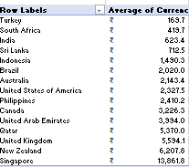
Exg : the analysis for average cost of two into INR by country wise.
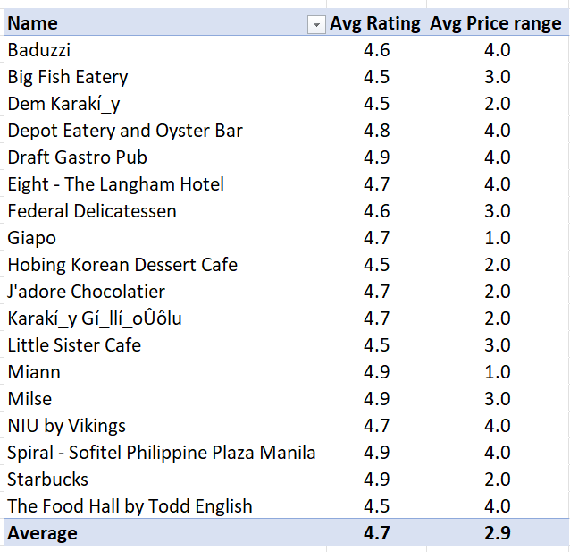

- Come up with the names of restaurants from the recommended states that are our biggest competitors and also those that are rated in lower brackets, i.e.1-2 or 2-3
Ans. The restaurants given table shows the Restaurants that are the competitors to our business in the country and Cities. These are the restaurants whose Rating is between 4.5 to 5 and has average price range in all 1 to 4 range.
Reference: -
There is only one hotel which comes is rated in bracket of 1-3 that is De Fontein Belgian Beer Café whose rating is 2.3.
Insights:
High-rated competitors show us what works well in these regions: focus on consistency, customer experience, and competitive pricing.
- Low-rated restaurants highlight common pitfalls we must avoid — e.g., poor service, long delivery times, or quality issues.
- The presence of many low-rated restaurants in the same states suggests there is still room for new entrants who can provide better quality and reliability.
- Competing directly with highly rated restaurants will require clear differentiation — either by pricing strategy, menu innovation, or exceptional service.
Recommendation:
We should position ourselves between affordability and quality, learning from the strengths of the top-rated competitors while capitalizing on the gaps left by the low-rated players. By maintaining strong customer satisfaction, we can gradually shift the market share away from poorly rated competitors.

- Which cuisines should we focus on in the newer restaurants to get better feedback? Does the choice of cuisines affect the restaurant ratings?
Ans. There are various cuisines in the all three countries but the cuisine on which we should focus should are the cuisine with Average rating from 4 - 5 in last 5 years
The price range for this cuisine is between 2 – 4 and are popular in the countries and the cities I have selected
Yes, Choice of cuisine Affects the restaurants rating as people prefer the cuisine which is regular for them and that are familiar with in their daily appetite.
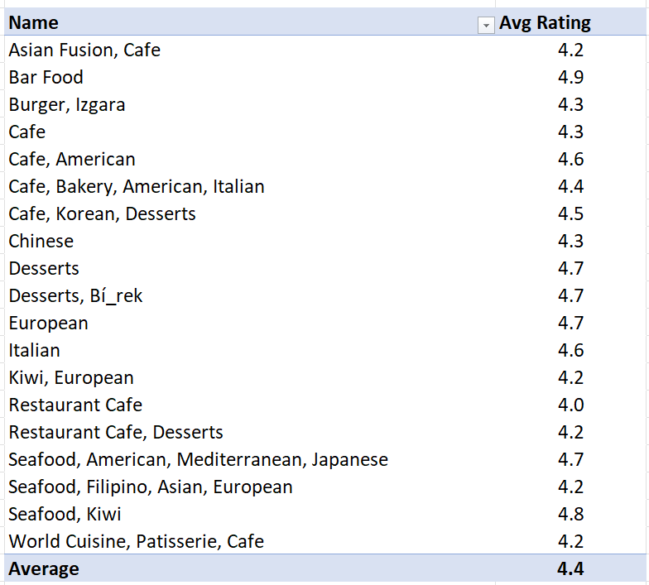
Reference: -

- According to our current data, should we go for online delivery and table booking? Does that affect the customer’s ratings?
According to the current data, the availability of online delivery and table booking does have an impact on customer ratings. Restaurants that provide these facilities generally tend to receive higher ratings compared to those that do not. This is because both options increase convenience and accessibility for customers:
- Online Delivery: Customers today prefer quick and reliable home delivery. Restaurants offering this service are rated better as it provides flexibility for those who cannot or do not wish to dine out.
- Table Booking: Especially in urban and premium markets, the ability to book a table in advance avoids long waiting times and enhances the overall dining experience.
On the other hand, restaurants without these features often fall into average or lower rating brackets, since they miss out on customer expectations of modern dining convenience.
Insights
- Positive Correlation – Restaurants offering online delivery and/or table booking show slightly higher average ratings.
- Customer Experience Factor – High ratings are not only about food quality but also about ease of access and service flexibility.
- Market Competitiveness – In highly competitive regions, lacking these features can put restaurants at a disadvantage.
Recommendations
- Adopt Online Delivery: Partner with food delivery platforms or set up in-house delivery to capture a wider customer base.
- Enable Table Booking: Implement online reservations, especially in metro cities and high-demand restaurants, to enhance customer satisfaction.
- Marketing Angle: Highlight these features in promotions as unique selling points (USPs).
- Gradual Rollout: If resources are limited, prioritize online delivery first (since it has broader demand), followed by table booking in urban hubs.
also increase sales for our restaurant as working professionals prefer online delivery only. But when come to cons, higher costs and delivery staff should be kept.

Row Labels | Count of Is_delivering_now
No | 7100
Yes | 2451
Grand Total | 9551

Row Labels | Count of Has_Table_booking
No | 8393
Yes | 1158
Grand Total | 9551

- Should the team keep the rate of cuisines higher? Will that affect the feedback? According to our data are the rates of cuisines and ratings, correlated?
The Correlation coefficient between cuisines price and customer rating has been calculated in the raw data sheet, the formula is used =CORREL(AA2:AA9552,S2:S9552) the correlation between Avg cost of two in INR & customer rating.
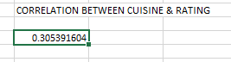
There is a mild link between the cuisines and the customer rating it’s not easy to encounter & make changes alone to improve the customer feedback, as you see the rating is 0.46 it’s a weak to moderate positive correlation between cuisine type and customer ratings. This means that certain cuisines are linked with better ratings on average, but the relationship is not extremely strong
Insights: Customers’ ratings are moderately influenced by the type of cuisine offered. Some cuisines are more popular or better perceived than others.
Since the correlation is moderate (not close to 1), ratings are also affected by other factors such as service quality, price, ambience, location, and online delivery availability.
Recommendations:
* Focus on High-Performing Cuisines
Identify which cuisines in your dataset correlate most strongly with higher ratings, and prioritize those for marketing, menu expansion, or new restaurant launches.
* Improve Around Cuisine
Since cuisine explains ratings only moderately, focus on enhancing complementary factors — customer service, ambiance, delivery speed, and pricing.
*Customer Segmentation
Target customers who prefer top-rated cuisines with personalized offers (e.g., discounts on trending cuisines).

- What is the distribution of the number of restaurants of different price ranges in all the countries?
Ans. The distribution of the number of restaurants across different price ranges varies from country to country. In general, most countries have a higher concentration of restaurants in the lower and moderate price if you can see
India → Majority of restaurants fall under Price Range 1 and 2 (budget and moderate), showing strong price sensitivity among customers.
UAE → Distribution is more balanced across all four ranges, with a noticeable share in Price Range 3 and 4, reflecting higher disposable income and premium dining culture.
New Zealand (Auckland) → Restaurants are mainly in Price Range 2 and 3, with fewer in the extreme low and very high categories, showing demand for mid-to-premium dining.
Philippines (Pasay & Taguig) → Skewed towards Price Range 1 and 2, with premium restaurants concentrated in urban/business districts like BGC (Taguig).

Insight:
- Developing countries (India, Philippines) → Skewed to low–moderate ranges → mass affordability.
- Developed countries (UAE, New Zealand) → More balanced spread → demand exists for premium dining as well.
- Premium restaurants exist but are fewer in number, catering to specific segments of the population in developed countries or metropolitan areas.

Recommendations
- In India & Philippines → Focus on affordable and mid-range restaurants + strong online delivery strategy for volume.
- In UAE & New Zealand → Position restaurants in mid-to-premium ranges, tapping into affluent locals and expats.
- Maintain a dual strategy: volume-driven growth in developing markets, premium niche positioning in developed markets.

- Explain your approach in brief for suggesting countries/cities in order to open new restaurants, if the objective and subjective questions would have not been given to assist you.
Ans. My general approach for opening new restaurant will focus on 4 things
- Cuisine – The cuisine which I will select will be Familiar and Favorable to the Locality where I am planning to open the restaurant.
- Price range – I will always go with medium and higher price like upper bracket of price range. I will consider the lower price if and only if it has high demand.
- Competition & High Demand - I will generally prefer the area with low competition and higher demand. Places like Hospitals, School & Colleges and working areas.
- Service – I will ensure that we provide the best service in that area where we are working
THE DASHBOARD WITH ALL THE REQUIREDMENT
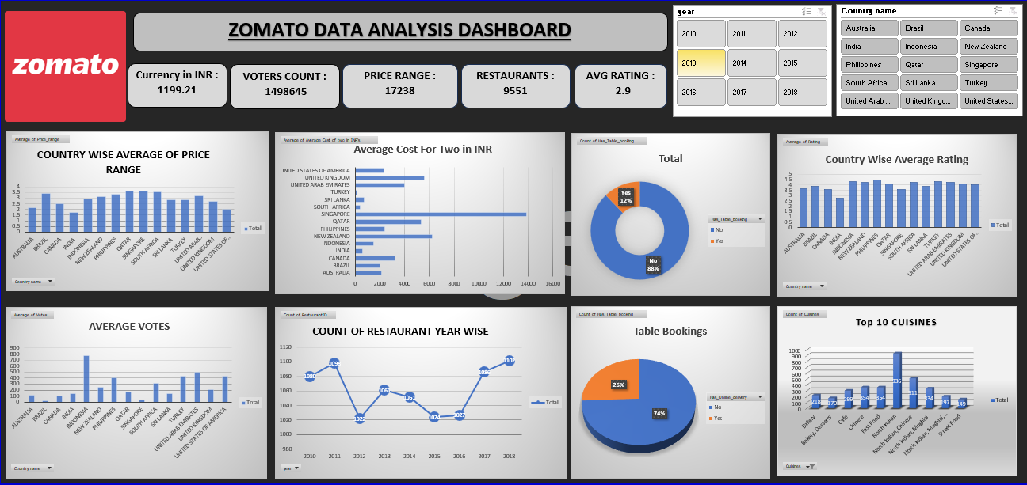
********** End OF The Report ************
Prepared by Shubham Patond

